**Selenium Automation Framework**

**Action Types**: Keywords which perform action on the web application.

|  |  |
| --- | --- |
| **Method Name** | **Description** |
| verifyTextFieldData: | Text field/Text box /Text area, data can be verified /validated. |
| readTitleOfPage: | Title of the current web page |
| click | click on button, checkbox and radio button |
| enterText | enter text into text field/text box/text area |
| readTextFieldValue | read data from the text field/text area , data which is already entered |
| alertAccept | pop up with “OK” and “Cancel” button. alertAccept will click on “OK” button |
| alertDismiss | pop up with “OK” and “Cancel” button. alertAccept will click on “OK” button |
| verifyTitleOfPage | Verifies the title of the current page |
| selectDropDownByVisibleText | If attribute is "Select", then select by visible text |
| selectDropDownByIndex | If attribute is "Select", then select by index |
| selectDropDownByValue | If attribute is "Select", then select by value |
| switchToFrame | switching to frame (Moving the control inside frame to identify elements) |
| switchOutOfFrame | Switching out of frame |
| selectFromListDropDown | If the drop down is of type list (Eg: <ul><li>), then go for this method |
| moveToNextPage | Navigating to next pafe |
| moveToPreviousPage | Navigating to previous page |
| maximizeWindow | maximize the window |
| readText | read the text from web page (it should not be text field) |
| quit | close the all the windows opened and exit the selenium session |
| close | close the current window |
| isDisplayed | to check element is displayed of not |
| isEnabled | to check the text field is enabled or disabled. |
| selectRadioButton | select the radion button |
| refreshPage | refresh the page |
| switchToParentWindow | moving the control to parent window |
| switchToChildWindow | Moving the control to new window |
| scrollElementIntoView | if element is not under visibility on the page, we will scroll the page manually rite. So the same way this function scrolls the web page and make the element visible on the page |
| readUrlOfPage | To get the url of the current page |
| navigateToURL | navigate to the URL |
| windowAuthenticationLoginName | Window in IE opened for entering username |
| windowAuthenticationPassword | Window in IE opened for entering password |
| mouseHover | mouse hover action |
| readTitleOfPage | get the title of the page |
| fileUploadinIE | Upload file in IE |
| verifyalertText | verify alert text displayed |
| sleep | sleep |
| certificateErrorsIE | SSL errors appear on IE |
| selectCheckBox | check box selection |
| DragAndDrop | Drag and drop the elements |
| Clear | clear the text in text field |
| verifyText | verify the text |
| downloadFileIE | download the file in IE and validate that the file name is correct |
|  |  |
| DropDownByMouseHover | Mouse hover action |

**IE browser settings**

1. For all the zones highlighted in red below, set the checkbox “Enable Protected Mode” to either checked or unchecked.
2. Set the Zoom level of browser to 100% in IE.

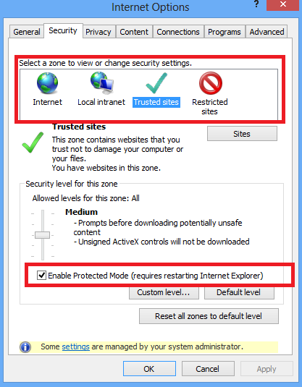

**Config.properties file**

Eg: Yahoo page

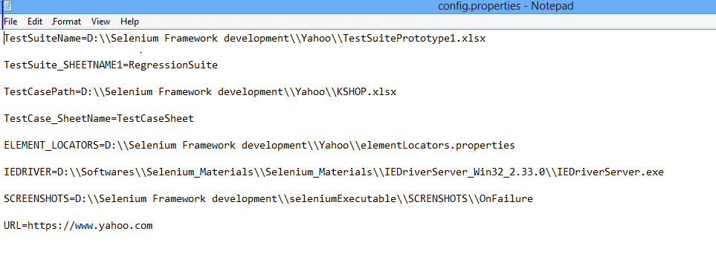

**Element Locators.properties file**

**Eg: Yahoo page**

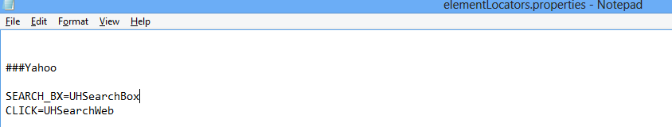

**TestCase sheet.xlsx**

Test Case sheet contains the actual test case to be executed.

Sheet Name- “TestCaseSheet” refers to the test cases sheet .

TC001_DS- If there exists test case by name “TC001” in “TestCaseSheet”. Assume that you need to pass data into the text field. So create a data sheet in the format “TestcaseName_DS”.

TestCaseName- Refers to the name of the test case.

TestStepID- should be uniq id in the entire sheet(It can be any number/text/string, but it has to be uniq for each row in the entire excel”).

TestSteps- For user understanding of the step. Any description can be entered which is only for user reference.It doesnot make any impact on the execution

MethodType- Based on the DOM objects type, we will write the method type.

|  |  |
| --- | --- |
| **MethodType** | **Description** |
| ID | If the element type in the DOM is ID |
| XPATH | If the element type in the DOM is xpath expression |
| NAME | If the element type in the DOM is NAME |
| CSS | Expression contructed in CSS |

ObjectLocators – Mapping from ElementLocators.properties file to Excel sheet.

Eg: SEARCH_BX is written in excel sheet. Same name is written in ElementLocators.properties file with the value “SEARCH_BX=UHSearchBox”.

Action Type- is the type of action which you will perform on the element in the page.

Data- Maps the data from data sheet

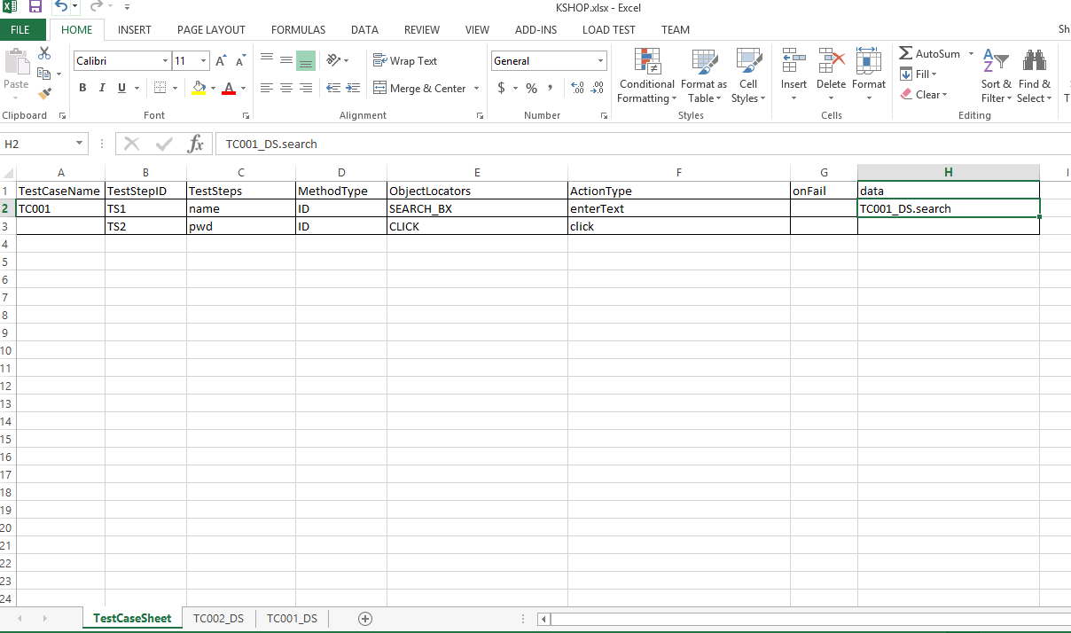

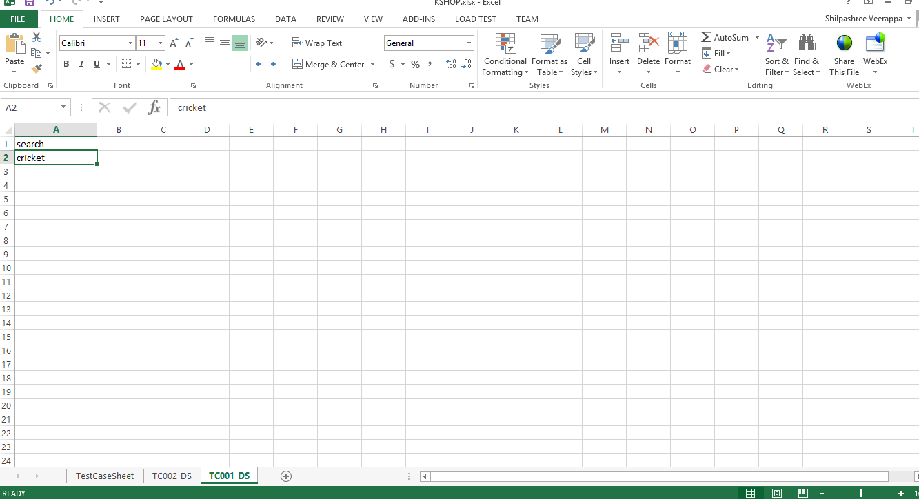

**TestSuite.xlsx**

Test suite will contain 2 columns.

Test case Name- Refers to the test case which is mentioned in the test sheet.

Execution status- “YES” will execute the test case and “NO” will not execute the test case.

